Personal details
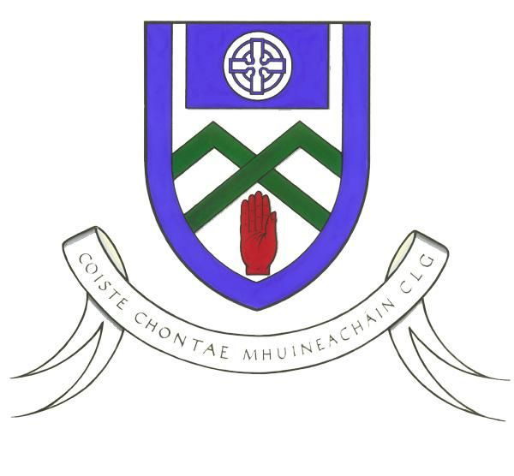

MONAGHAN Kelloggs GAA

Cul Camps
ASSISTANT Coaches
Application Form

- Name: _____________________________
- Address:________________________________________________________________
- Date of Birth: ________________________ Club: _____________________________
- Football ⁭ Hurling ⁭ Both ⁭
(Please tick appropriate box of sport you would prefer / are qualified to coach)

Contact information
- Phone number
Home: ________________Mobile: _______________E-mail: ____________________________

Education; (Currently studying at what level please tick)
- Secondary School - Junior Certificate _____ Leaving Certificate _____

- Third level
If ticked this box please indicate:

What College: _________________ What Course: _______________________

If not at college please state;
Your occupation: ______________________________________________

Current Employment Status: __________________________________ PPS No.________________

'If unemployed please state whether on UA, UB, Disability or other - specify' _____________.

If on UA, UB, Disability or Other, when you are working on the camps will you be coming off one of these Social Welfare Schemes? Yes __ No __

Coaching Information
- Coaching Experience: (Please indicate information in bullet format) ____________________________________________________________________________________________________________________________________________________________________________________________________________
_______________________________________________________________
- Coaching Qualifications:PLEASE PROVIDE COPIES OF COACHING QUALIFICATION _____________________________________________________________________________________________________________________________________________________________________________________________________________________________________________

- What is your current involvement in Coaching or Playing Gaelic Games?

- Have you completed GAA Garda vetting procedure & received clearance?

YES ___ NO ____
If yes please provide a copy. If no please apply ASAP through your clubs Childrens Officer.
Availability to work: Please tick all the boxes if you are available to coach on all camps or selected boxes if only available for certain full week camps. Coaches must attend the full week of each camp. Changes by you to the committed weeks of work will not be accepted. Therefore think carefully before completing the form.

MONAGHAN Kelloggs GAA

Cul Camps
ASSISTANT Coaches
Application Form

VENUES | DATES | CAMP ACTIVITIES  F-H/C-HB | CAMP COORDINATOR | COORDINATOR CONTACT | Please tick box
WEEK 1
Carrick Emmetts GAA Club | 30th June – 4th July | F / H /C / HB | Pauric Dowdall | 0872163580
Clontibret | 30th June – 4th July | F / H / C | Marty Corey | 087-2644733
Toome | 30th June – 4th July | F / H / C | Colin Malone | 0877882859
Clones | 30th June – 4th July | F / H / C | Ann McKenna | 087 7580150
WEEK 2
Castleblayney | 7th – 11th July | F / H / C | Colin Malone | 086-3515950
Inniskeen | 7th – 11th July | F / H / C | Pauric Dowdall | 0872163580
Monaghan | 7th – 11th July | F / H /C / HB | Ann McKenna | 087-7580150
WEEK 3
Ballybay | 14th – 18th July | F / H / C | Colin Malone | 086-3515950
Killanny | 14th – 18th July | F / H / C | Pauric Dowdall | 0872163580
Truagh | 14th – 18th July | F / H /C / HB | Ann McKenna | 087-7580150
Eire Og | 14th – 18th July | F / H / C | Marty Corey | 087-2644733
WEEK 4
Scotstown | 21st – 25th July | F / H / C | Ann McKenna | 087-7580150
Latton | 21st – 25th July | F / H / C | Colin Malone | 086-3515950
Donaghmoyne | 21st – 25th July | F / H / C | Pauric Dowdall | 0872163580
Magheracloone | 21st – 25th July | F / H / C | Marty Corey | 087-2644733
WEEK 5
Emyvale | 28th July – 1st Aug | F / H / C | Ann McKenna | 087-7580150
Aghabog | 28th July – 1st Aug | F / H / C | Colin Malone | 086-3515950
Corduff | 28th July – 1st Aug | F / H / C | Pauric Dowdall | 0872163580

ANYBODY WISHING TO RECIEVE SUMMER CAMP WORK WILL HAVE TO UNDERATKE A PRACTICAL ASSESSMENT & ATTEND A TWO DAY INSERVICE TRAINING PROGRAMME WHICH WILL TAKE PLACE ON THE LAST WEEK OF JUNE

Please return Application Form by; Friday 30th May

To: Paul O’Connor
Football Development Manager
Monaghan County Training Grounds
Cloghan, Annyalla.
Co. Monaghan
086-8374827
developmentmanager.monaghan@gaa.ie

